React Sidebar example

Desktop mode: Will display a sticky sidebar.

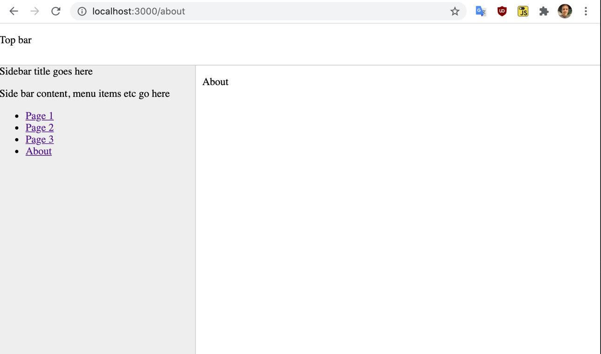

Mobile mode: Will display a menu with a show/hide option.

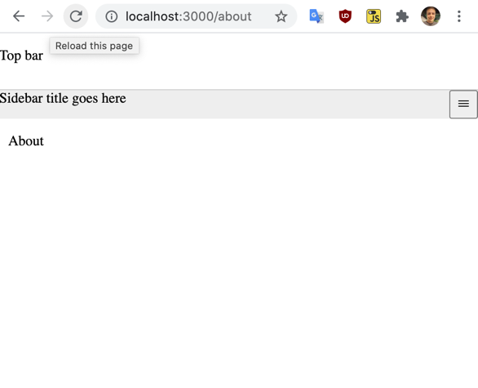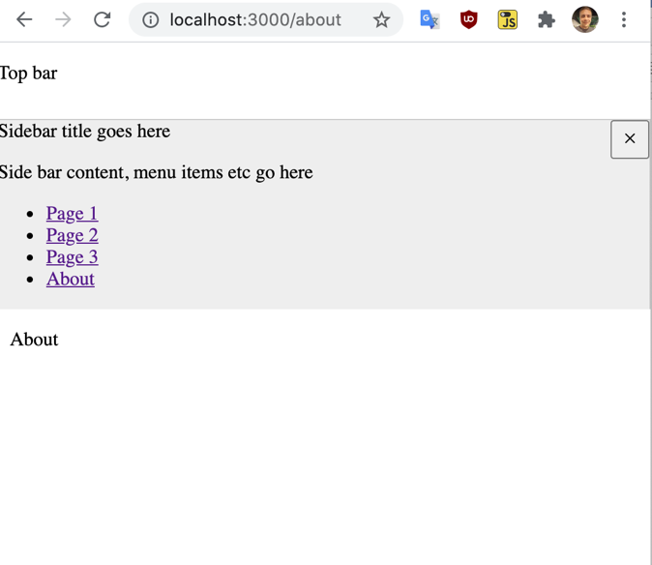

App.jsx

import { useState } from 'react';

import { BrowserRouter as Router, Switch, Route, Link } from "react-router-dom";

import './App.css';

import menuIcon from './icons/menu-outline.svg';

import closeIcon from './icons/close-outline.svg';

function TopBar() {

return (

<div className="TopBar">

<p>Top bar</p>

</div>

)

}

const items = [

{ label: "Page 1", href: "/page1" },

{ label: "Page 2", href: "/page2" },

{ label: "Page 3", href: "/page3" },

{ label: "About", href: "/about" }

]

function SideBar() {

const [ visible, setVisible ] = useState(true);

return (

<div className="SideBar">

<div className="SideBar_banner">

Sidebar title goes here

<button className="SideBar_visiblitybutton" onClick={()=>setVisible(! visible)}>

<img src={ visible ? closeIcon : menuIcon } />

</button>

</div>

<div className={(visible) ? "SideBar_content" : "hideContent SideBar_content"}>

<p>Side bar content, menu items etc go here</p>

<ul>{ items.map((item)=>{

return(

<li><a href={item.href}>{item.label}</a></li>

)

})}

</ul>

</div>

</div>

)

}

function Page1() { return ( <p>Page 1</p>) }

function Page2() { return ( <p>Page 2</p>) }

function Page3() { return ( <p>Page 3</p>) }

function About() { return ( <p>About</p>) }

function Welcome() { return ( <p>Welcome</p>) }

function Content() {

return (

<div className="Content">

<Router>

<Switch>

<Route path="/page1"><Page1/></Route>

<Route path="/page2"><Page2/></Route>

<Route path="/page3"><Page3/></Route>

<Route path="/about"><About/></Route>

<Route><Welcome/></Route>

</Switch>

</Router>

</div>

)

}

function App() {

return (

<div className="App">

<TopBar />

<SideBar />

<Content />

</div>

);

}

export default App;

App.css

:root {

--color-layout-border: #ccc;

--color-layout-sidebar: #eee;

}

html, body, #root {

height: 100%;

}

.App {

height: 100%;

display: grid;

/* Grid will be a 2x2 design.

1st row: Merge both cells together. 64px high.

2nd row: Left cell 300px wide, right cell all remaining space. */

grid-template:

"TopBar TopBar" 64px

"SideBar Content" auto / 300px auto;

}

.App .SideBar .SideBar_visiblitybutton {

display: none;

}

@media only screen and (max-width: 640px) {

/* Rules for devices with screen <= 640px wide */

.App {

height: 100%;

display: grid;

/* Grid will be a 1x3 design. */

grid-template:

"TopBar" 64px

"SideBar" auto

"Content" 1fr;

}

.App .SideBar .SideBar_visiblitybutton {

display: block;

float: right;

height: 32px;

width: 32px;

}

.hideContent {

display: none;

}

/* END: Rules for devices with screen <= 640px wide */

}

.App .TopBar {

grid-area: TopBar;

border-bottom: 1px solid var(--color-layout-border);

}

.App .SideBar {

grid-area: SideBar;

height: 100%;

border-right: 1px solid var(--color-layout-border);

background-color: var(--color-layout-sidebar);

}

.App .Content {

grid-area: Content;

padding-left: 10px;

height: 100%;

}